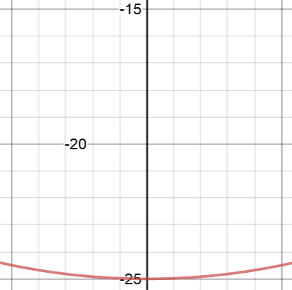

**Before the Throw**

**Fc**

**V**



**After the Throw**

**Vx**

**V**

**Vy**

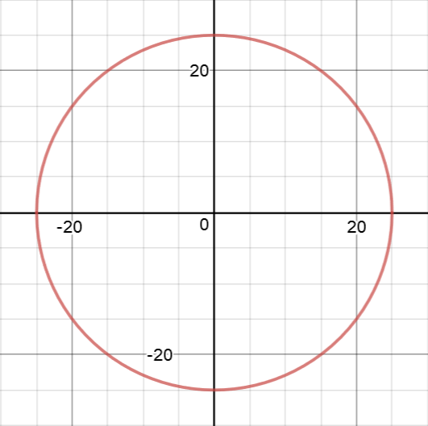

**The Coordinate System**

Vy = 0

**V0y**



Landing Point

Capsule 2

Capsule 1

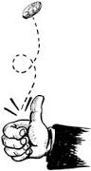

**…but the station forces you up around the curve.**

**Your body is moving to the left…**

**Where would a coin toss end up?**

**In a rotating station…**